**1.Use  
a for loop to print the first 10 multiples of 3.**

**Output:**

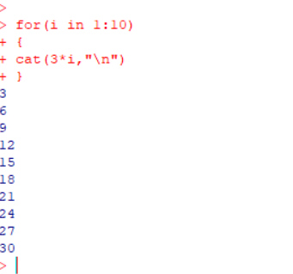

**2.Write  
an if-else statement to check whether a number x is positive, negative, or zero.**

**Output:**

